Facial Recognition/Detection using a Neuro-Fuzzy Inference System

**Farhan Ahmad Shreya Nandanwar Parth Ganeriwala Arshiyan Ulde**

**BITS Pilani BITS Pilani BITS Pilani BITS Pilani**

**Dubai, UAE Dubai, UAE Dubai, UAE Dubai, UAE**

**2018AAPS0097U 2018A7PS0218U 2018A7PS0131U 2018A7PS0133U**

**ECE Dept. CS Dept. CS Dept. CS Dept.**

**Abstract- Facial recognition has been on the rise since the advent of the pandemic and we have also seen an increase in computer vision and machine learning since the start of the 21st century. This paper focuses on a neuro-fuzzy model which is divided into two parts. The first step focuses on image pre-processing which is face detection and landmark extraction of the overall face, particularly, the points of interest on the face such as the corners of the mouth, points on the eyes, along the eyebrows, nose and jaw will be detected and then stored. In the second step, based on stored extracted features, the neuro-fuzzy inference system then recognizes to whom the detected face belongs to. This paper shows that, neuro-fuzzy system can better suit the face recognition process and provide improved results than other common techniques.**

**Keywords- *Neuro Fuzzy Logic, Face Detection, Face Recognition, Neural Networks. Feature Extraction.***

**I. INTRODUCTION**

The usage of artificial intelligence is being applied widely in various fields of computational sciences. Main attribute of this concept is the ability of autodidactic and self-predicting the desired outputs. The learning can be done in a supervised or an unsupervised manner. Neural Network study and Fuzzy Logic are the basic areas of artificial intelligence concept. Adaptive Neuro-Fuzzy study combines these two methods and uses the advantages of both methods.

The issue of identification and verification is actively growing in the area of research. Face, Voice, Lip Movements, Hand geometry, Odours, Gait, Iris, Retina, Fingerprint are the most used verification methods. These characteristics of a person are called biometrics. The biometrics have a significant advantage as biometric features of individuals are not easily transferable, are unique to every person and cannot be misplaced or stolen. Facial Detection/Recognition is one of the methods to recognise the features of the individuals. Research in this area has been conducted for a long time now and the data is stored in the pre-stored image database.

Face detection is an area of various research disciplines ranging from image processing, recognising patterns and AI. Face detection and recognition are introductory steps to a range of applications such as personal identification and video surveillance and the detection efficiency of the applied algorithm highly influences the performance of these systems. Given an image, the goal of the face detection algorithm is to identify the location of the face in the image. Face detection is an important part of face recognition as it is the first step to any automatic face recognition system [1]

Facial recognition is a technique based on visual pattern recognition, in which an arbitrary image is given as an input to the system and a person’s face is identified and recognised in the output. There is a huge complexity in face recognition and because of the large variability of conditions to process the diversity of human faces in images, a Neuro - Fuzzy Inference System (NFIS) is used. [2]

Biometric verification using face recognition has become a standard nowadays and there has been much progress in improving the accuracy of the algorithms and techniques associated with face detection and recognition.

The outline of the paper is as follows: Section II is Background Theory which discusses the basics of the Neuro-Fuzzy model. Section III describes the Issues regarding the Face Recognition/ Detection model briefly. Section IV deals with the Literature Survey and Analysis of Neuro-Fuzzy Inference module. Section V discusses the results and concludes the research paper.

**II. BACKGROUND THEORY**

The following sections describe the basic concepts required for the working of the model-

**a) Neural Network**

Neural Network is the most researched topic under AI. The intelligence of the neural network emerges from the collective behaviour of the neurons, where each neuron does a fixed amount of computation parallel.

There are two stages in a neural network: training stage and testing stage.

In the training stage, we train the neural network with a set of images, which is where feature extraction comes into play. These features are then stored in the database which are then used in the testing stage. In the testing stage, we get to know about the accuracy of the neural network as the features extracted in this stage are compared to the features stored in the database.

**a.1) Face Detection**

Training a neural network for face detection is hard as here we have to classify images as “face is present” or “face is not present”. We can find a limited dataset for the class “face is present” but the training set for the class “face is not present” can grow rapidly which in turn becomes difficult for us to represent. Hence, we avoid this problem by selectively adding images to the training set as the training of the model continues.

When the image is given as an input to the model, a filter is applied at every location of the image which gives output in +1 or -1 form denoting the presence or absence of a face respectively. If the image happens to be bigger than the window size, it is subsampled by a factor of 1.2 and the filter is applied again at every scale.

The filtering algorithm has a pre-processing step in which first the intensity across the image is equalized and then we fit a function which varies linearly across the window to the intensity values in the oval region inside the window. While computing the lighting variation across the face, the pixels outside the oval region are ignored. The function approximates the overall brightness of each part of the window so as to compensate for varying lighting conditions. After this, histogram equalization is performed which non-linearly maps the intensities inside the oval region. This helps to compensate for the differences in the computer gains and in some cases even increases the contrast.

This pre-processed image is then passed to the neural network which comprises hidden units used to detect localized features for face recognition. Here stage one of a neural network based filter is over. The drawback is that this system of a single neural network will have false detections. To overcome this problem, there is a stage two to reduce errors. In our model, stage two is carried out using fuzzy logic rather than neural networks. [3]

**a.2) Face Recognition**

The neural network is used to extract different facial features like the position of lips, eyes, corners of the mouth etc. from the images with the help of hidden units. The method to extract these features vary according to the situation. There are several ways to extract features from the images like Principal Component Analysis (PCA) which is generally used to reduce the data dimensions, Scale Invariant Feature Transform (SIFT) etc. [4]

**b) Fuzzy Logic**

Fuzzy logic is based on the degree of truth where truthness can possess a value anywhere between 0 and 1, unlike the normal true or false Boolean value (1or0).

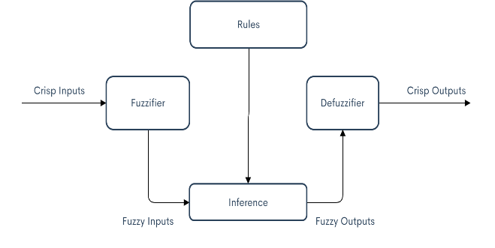

This is used in facial recognition for increasing the accuracy and performance of the model. The accuracy of the fuzzy logic is defined by two parameters namely Gradient and Epochs. Gradient is used to minimize the level of error by finding the slope of error and then modifying the weights and biases until the error is minimized. There are three parameters which define epochs: number of epochs, time and value. When the number of epochs is less, then the neural network learns with slight reiterations. The network is said to have higher accuracy when the value of epoch is less. [5] [6]

**c)** **Neuro-Fuzzy Inference Model**

The neuro-fuzzy inference model has a derivation framework that maps input qualities to include participation capacities, input enrolment capacities to rules, principles to an arrangement of yield attributes, yield attributes to yield enrolment capacities, and the yield participation capacities to a solitary esteemed yield or a choice related with the yield. A neuro-fuzzy system finds parameters by exploiting the approximation techniques of neural networks.

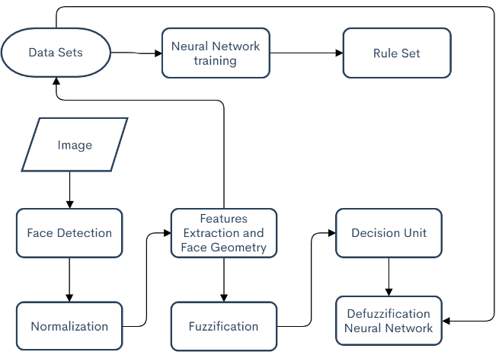

Presented solution uses singleton as a russification method and neural network as a defuzzification block. This scheme can be mathematically described using following expression:

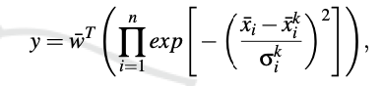

where:

* *w* ̄ is a vector of neural network weights,
* *i* is a number of input variables,
* *k* is a number of membership functions for each variable universe,
* *n* is a number of all possible rules, which is a product of number of input variables with number of membership function,
* *x* ̄*k* is a mean value of normal distribution, which is used here as membership function,
* σ*k* is a sigma parameter (standard deviation) for a normal distribution.

Since face recognition requires a defined solution which means that it fits specific cases and there is no need for a human expert, therefore a multilayer neural network with one output node is the best way to represent this model. [7] [8] [9]

**III. ISSUES FACED**

Face is an important part of human beings and requires detection for various purposes. It requires accurate techniques and high precision. With the requirement of high precision, we encounter various issues in recognising faces as explained below-

**a) Aging-**

Face in the form of characteristic value changes as we grow and reflects aging which has vital significance in facial detection. Aging factor is measured over a long period of time for accuracy. Aging effect descriptor is done for various groups of different ages were analysed for checking similarity index. [10]

Facial recognition depends on the features of the face and basic properties such as wrinkles, marks and spot eyebrows etc. An Active Appearance Model (AAM) technique is brought in for reduction of image dimension in face recognition process. [11]

**b) Occlusion-**

This is an issue faced when more than one person is in the vision of detection or the face is too close to the camera. There were two methods this problem could be solved. A partially occluded system with a large database and a structured sparse dictionary approach. The dictionary approach had a faster algorithm proposed for occlusion and also had lower computational costs as compared to the other method. [12]

Mustafa M. Alrjebi et al [13] had proposed against occlusion using 2-D model. They fused colour information and devised a new local representation and applied partitioned sparse sensing recognition for improving accuracy. This improved the recognition rate on the various data sets it was applied to.

**c) Facial Expressions-**

As expressions change, various features that are dislocated on the face and can often cause a problem in recognising the features as recorded. Yulan Guo et al. [14] proposed an expression invariant 3-D model which was based on feature and matching shape which finalizes a local geometric feature with the help of global similarity between the faces. This had achieved the recognition rate of 97% and a verification rate of 99.01% for having either a neutral expression or an expressive reaction.

**d) Poses-**

When there are different poses of a person in the vision of detection and the mechanism has been trained only to recognize a particular region of the face, a different pose can cause only partial identification and recognition of the face.  Li-Fang Zhou et al. [15]  had proposed a proper face recognition with Local Binary Patterns and Huffman coding. They applied the divide and rule technique which registers different parts of the faces instead generally applied SRC to improve the accuracy of the recognition.

**e) Facial advances-**

Facial recognition becomes even more challenging when an image only differs by very less variations. The strategy of coarse to fine was used to identify features in different poses. Half face matching algorithm was introduced based on geometric structure based search and the technique that gave the highest accuracy was Fusion algorithm/ RF classifiers with 99.07% which uses the application of visible and thermal imaging. [16]

**IV. LITERATURE SURVEY**

Earlier face detection/recognition systems have ranged from static to dynamic face identification implemented for commercial use. Face recognition can be regarded as a set of common biometric properties used by humans to recognize people. Neural networks have been used to extract features of the face and fuzzy logic have been used to improve the accuracy. There have been various simulations performed where the results suggest that when taken alone, features are sometimes sufficient for facial recognition [17]

Integral image has also been used to compute the features to minimize the computation time which results in a classifier which is computationally efficient, since only a small number of features need to be evaluated during the runtime. [18].  Experiments have also been conducted by using a model which combined many Neural Networks for matching geometric features of human face using AdaBoost and ANN approaches but they do not achieve good results of performance time and detecting rate. [19] AdaBoost method is one of today’s fastest algorithms but the false face detecting rate is rather high which has brought down the accuracy by a large margin. The model has to compute the possibility of facial images being captured in unconstrained and uncontrolled environments, therefore, the recognition performance of the existing techniques is low.  Feature extraction was also performed with an edge detection technique to reveal the outline of the face. Other facial features were also found using the facial outline and eyes’ location and fuzzy linguistic variables were used to settle normalization [20]

The use of a modified ME structure to improve human face recognition was also tried which consisted of four modified experts such as fuzzy MPLs and a gating network. In the modified ME, the training rules were modified so as to keep the weights updating with the degree of ambiguity [2]. The recognition rates that were achieved by the modified ME model resulted to be higher than that of a single MLP, Fuzzy MLP, and the ME with MLPs as experts trained without the fuzzy system. This suggests that a combination of a fuzzy system with neural networks would prove to be far more effective than the individual selves. The use of a Self-Organizing Map (SOM) to measure image similarity was also experimented on and it was found that a good extracting feature ability with the average recognition rate of 92.40% was achieved because Self-Organizing Maps are topologically ordered [21]

Facial Detection and recognition have also been tried by using mathematical models such as Harley’s law of Cosine and then calculating the facial feature locations according to Heron’s formula [22] Neural networks were used to train and test the datasets whereas a fuzzy logic system was used to improve the performance in face recognition. [6]

Matlab research has also shown that face recognition using image patches and fuzzy classification method which uses pictures partitioning and a linear feature extraction method, which rated each item has proved to be effective [23] Research was done using an algorithm based on Eigen face for skin detection and a Neuro-Fuzzy system was implemented for face recognition which yielded an overall performance of 95%. The neuro-fuzzy inference method was used to increase the efficiency of face recognition approach [9].

A comparison was done between Hybrid Neuro-Fuzzy (ANFIS) and Neural Network recognition systems (BPNN) and Principal Components Analysis (PCA) was used to reduce the data. It was found out that with a 20 subject range, the models (BPNN and ANFIS) gave better result, but the results were not enhanced when the number of subjects was increased [4].

The ANFIS framework utilizes settled enrolment works which are picked with discretion and a rule set is set which is done by the understanding of the attributes of the factors in the model [7] The recognition rate is more effective in ANFIS-PCA methodology than the neutral network existing methodology and to improve the recognition rate a combination of multiple feature extraction approaches with a multi class learning classification methodology will prove to be effective [24]. Based on the obtained results, research shows that a neurofuzzy approach fits better face recognition process than other most popular classification techniques, especially neural network, which is also a part of neurofuzzy system [8]. Neuro-fuzzy (NF) fusion in a multimodal face recognition using PCA, ICA and SIFT is done and an accuracy of almost 95% is achieved [5] which shows that this is the most efficient and accurate method of face detection and face recognition.

**V. SIMULATION & RESULTS**

There are three stages in the results of the proposed algorithm, data collection, face detection and face classification.

(i) Data collection-

In this process, a video of the subject is captured using an algorithm which saves the file and another code captures the stills, frame by frame and generates a dataset using the OpenCV and numpy libraries of python. The dataset produced then is shifted to the folder containing the face detection and face classification algorithms.



[Video being captured by the algorithm]

(ii) Image Pre-processing –

We extract the embedding of the faces present in the dataset by using a pre-trained face detection model along with a pre-configured embedding model and then output it as a pickle file namely – ‘embeddings. pickle’. We load our serialized face detector and face embedding model and then use our dataset and initialize the lists of extracted facial embedding and the corresponding names of the people in the dataset. We extract and load each image and then resize it to have a width of 600 pixels while keeping the aspect ratio constant and then take the image dimensions. Using OpenCV's deep learning based face detector we localize the faces in the input image, and assume that the input image has only one face so the bounding box with the largest probability is taken and this helps in filtering out the weak detections. Using feature extraction, we calculate the Region of Interest and grab the ROI dimensions. We pass these dimensions to a blob using OpenCV and then through the face embedding model and obtain the 128-d quantification of the face and serialize each of these with the names of person it belongs to.

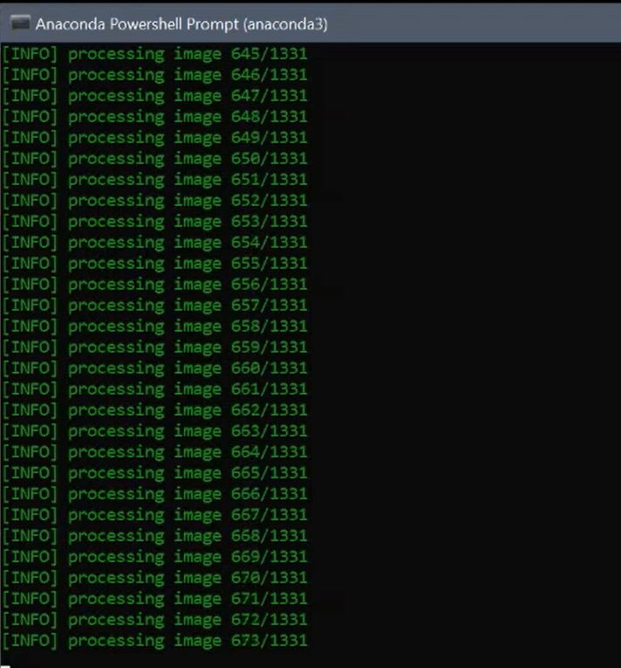

[Images getting processed taken from the video]

(iii) Training-

We have used an algorithm based on the Fuzzy ARTMAP [25] architecture which is a new neuro fuzzy model which achieves a synthesis of fuzzy logic and adaptive resonance theory (ART) [26] neural networks. ARTMAP is a class of neural network architectures that perform incremental supervised learning of recognition categories in response to the input vectors present. This is done by exploiting a formal similarity between the subsets of the fuzzy data and the ART categories namely choice, resonance and learning. To tackle the problem of category proliferation, due to which categorization precision reduces, ARTMAP introduces a new minmax learning rule. It normalizes the input vectors which minimizes the prediction error and maximizes code compression.

Using the generated serialized database of facial embedding pickle file and the OpenCV's DNN model, we include the ARTMAP architecture to train the model to detect and recognize faces provided in the dataset. While training, we train the model used accept the 128-d embedding of the face and produce the actual face recognition. In the ARTMAP architecture, we use the parameters namely: feature space, choice, learning rate, vigilance, category of the person dataset, T vector, the original training label for each data and also registering new faces during the face recognition. The architecture is based on fuzzy min learning functions where the choice function evaluates the similarity between the input and each category of the dataset. The weights are corrected depending on the T Vector input and the vigilance parameter.

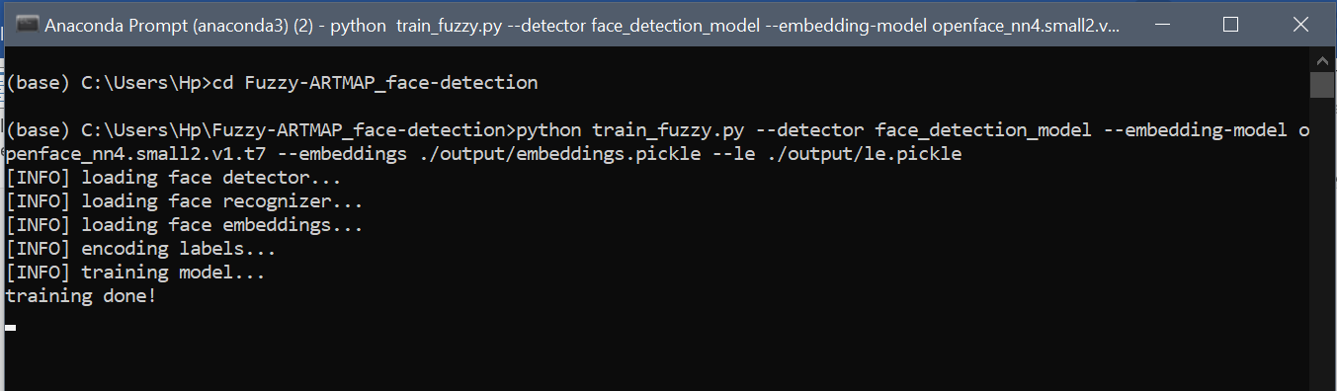

[Training]

(iv) Face Detection-

OpenCV’s dnn module has been included for the purpose of image classification for face detection. The advantage of including this module is that it helps to implement the deep neural networks which uses popular frameworks such as Caffe, Tensorflow, Torch, Darknet, ONNX, to pre-train. The dnn module included in the code uses the Caffe model for face detection. This has been done so as to reduce the computational cost by re-using the models which have already been trained.

Caffe model is developed by Berkeley AI Research(BAIR) and by community contributors. It is a framework which supports various architectures focussing on image classification and image segmentation. The data is collected from ImageNet project to train this model.

(v) Facial Recognition-

For real-time face recognition and face registration in case of unknown classes, we use the trained models, and predict the faces available in the VideoStream. We extract individual frames from the VideoStream preferably from the webcam and resize the frame to have a width of 600 pixels while maintaining their aspect ratio and then pass the image dimensions. Using OpenCV's DNN model, we construct a blob from the image and localize the faces in the frame. We extract the confidence which is basically the probability associated with the prediction and filter out the weak detections by using the confidence parameter which has a value of 0.5. Using OpenCV, we compute the (x,y) co-ordinates of the bounding box for the face and extract the ROI of the face which goes through the trained facial embedding model. ARTMAP then predicts the face and displays it on the screen along with the label of the person that face belongs to otherwise displaying "Unknown" on the detected face image. To register a face in real time we use threads which keep the system intact and provide a seamless method where the input frame is taken as a dataset and then the entire training process is processed on another thread while the other thread carries on with the face recognition.

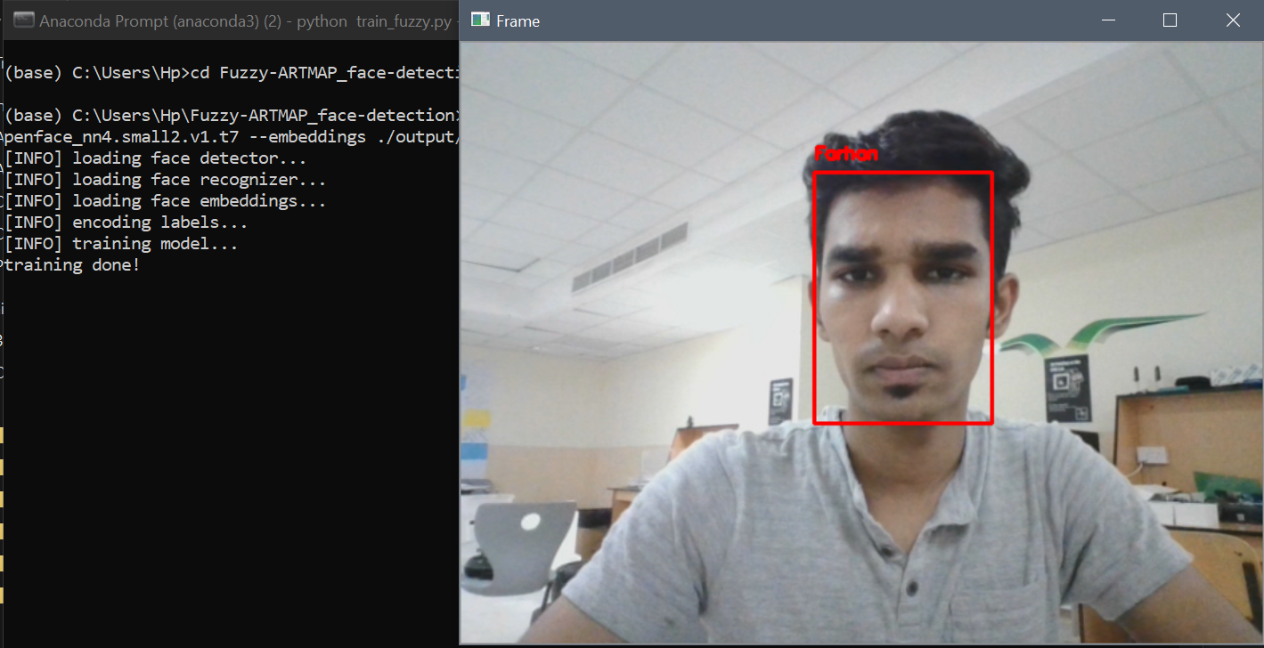

[Face Recognition]

**VI. CONCLUSION**

This paper deals on the various techniques to which face detection can be performed with feature extraction and face recognition using a neuro-fuzzy inference system which is the most efficient way as shown by the Figure below. We have used an algorithm based on the Fuzzy ARTMAP [25] architecture which is a new neuro fuzzy model which achieves a synthesis of fuzzy logic and adaptive resonance theory (ART) [26] neural networks. The system deals with the normalization of the image samples using filtering process which filters out the redundancies in the image and also the feature extraction process using principal component analysis and the classification approach using NFIS (Neuro Fuzzy Inference System) which shows that the proposed system achieves high recognition rates and predicts the authentic user by recognizing the face from the training dataset in the real-time testing phase.  This model has proved to be efficient giving high accuracy in a considerable less amount of time with a small enough dataset. Further improvements can be made by expanding our dataset and having a better data cleaning process and updating the weights to improve the confidence and vigilance parameters in the ARTMAP architecture.

# **REFERENCES**

|  |  |
| --- | --- |
| [1] | M. J. Paul Viola, "Robust Real-time Object Detection," SECOND INTERNATIONAL WORKSHOP ON STATISTICAL AND COMPUTATIONAL THEORIES OF VISION – MODELING, LEARNING, COMPUTING, AND SAMPLING, Vancouver, 2001. |
| [2] | R. E. A. H. Nina Taheri Makhsoos, "Face Recognition Based on Neuro-Fuzzy System," IJCSNS International Journal of Computer Science and Network Security, Tehran, 2009. |
| [3] | S. B. T. K. Henry A. Rowley, "Neural Network-Based Face Detection," Pittsburgh, 1996. |
| [4] | A. S. M. H. HaronM. Ahmed Omer, "Face Recognition Systems using Neural Network and Adaptive Neuro-Fuzzy Inference System (ANFIS)," INTERNATIONAL JOURNAL OF RESEARCH IN ELECTRONICS AND COMPUTER ENGINEERING, Aden, 2019. |
| [5] | H. A. Abdullah, "Neuro-fuzzy inference system based face recognition using feature extraction," TELKOMNIKA Telecommun Comput El Control,, Baghdad, 2020. |
| [6] | S. G. B. B. a. C. N. Shweta Mehta, "Face Recognition Using Neuro-Fuzzy Inference Systems," International Journal of Signal Processing, Image Processing and Pattern Recognition, 2014. |
| [7] | D. A. K. D. D. G. S. S. Vinodpuri Rampuri Gosavi, "Adaptive Neuro Fuzzy Inference System for Facial Recognition," IOSR Journal of Electrical and Electronics Engineering, Aurangabad, 2019. |
| [8] | E. P. a. M. B.-F. Wojciech Biniek, "The Face Recognition Processes - Neurofuzzy Approach," International Joint Conference on Biomedical Engineering Systems and Technologies, Wroclaw, 2018. |
| [9] | S. H. &. A. SHAOUT, "FACE RECOGNITION USING NEURO-FUZZY AND EIGENFACE," International Academy of Science Engineering and Technology, Ammam. |
| [10] | P. K. W. P. M. R. Michał Bereta, "Local descriptors in application to the aging problem in face recognition," krakow, 2013. |
| [11] | S. &. J. J. &. L. S. &. C. H. &. K. I.-J. &. K. J. Choi, "Age Face Simulation Using Aging Functions on Global and Local Features with Residual Images. Expert Systems with Applications," 2017. |
| [12] | X. Y. T. Weihua Ou, " Robust face recognition via occlusion dictionary learning," 47(4):1559-1572., 2014. |
| [13] | M. &. P. N. &. L. W. &. L. L. Alrjebi, "Face Recognition against Occlusions via Colour Fusion using 2D-MCF Model and SRC. Pattern Recognition Letters," 95. 10.1016/j.patrec.2017.05.013, 2017. |
| [14] | Y. L. ,. L. ,. Y. W. ,. M. B. F. S. Yulan Guo, "Expression-invariant 3D face recognition based on feature and shape matching," 2016. |
| [15] | Y.-W. W.-S. L. J.-X. X. Li-Fang Zhou, "Pose-robust face recognition with Huffman-LBP enhanced byDivide-and-Rule strategy," 2018. |
| [16] | S. Shilpi Singh, "Techniques and Challenges of Face Recognition: A Critical Review," 8th International Conference on Advances in Computing and Communication, Faridabad, 2018. |
| [17] | B. B. Y. O. a. R. R. Pawan Sinha, "Face Recognition by Humans Nineteen Results All Computer Vision Researchers Should Know About," Cambridge, 2006. |
| [18] | N. O. K. F. J. M. K. Shahrin Azuan Nazeer, "FACE DETECTION USING ARTIFICIAL NEURAL NETWORK APPROACH," Centre for Artificial Intelligence and Robotics (CAIRO), Kuala Lampur, 2007. |
| [19] | T. H. Le, "Applying Artificial Neural Networks for Face Recognition," Hindawi Publishing Corporation, Ho Chi Minh City, 2011. |
| [20] | R. &. G. G. Vyas, "FACE RECOGNITION USING FEATURE EXTRACTION AND NEURO-FUZZY TECHNIQUES.," International Journal of Electronics and Computer Science Engineering.. |
| [21] | K. B. Shamla Mantri, "Neural Network Based Face Recognition," MITCOE, Pune, Pune, 2011. |
| [22] | A. &. A.-A. O. &. A. M. Tamimi, "Real-Time Group Face-Detection for an Intelligent Class-Attendance System," International Journal of Information Technology and Computer Science, 2015. |
| [23] | E. Parcham, "Face Recognition using a Fuzzy Approach," MATLAB Central File Exchange, 2020. [Online]. Available: https://in.mathworks.com/matlabcentral/fileexchange/45777-face-recognition-using-a-fuzzy-approach. |
| [24] | C. S. k. Tadi Chandrasekhar, "Face Recognition System using Adaptive NeuroFuzzy Inference System," International Conference on Electrical, Electronics, Communication, Computer and Optimization Techniques, Vishakapatnam, 2017. |
| [25] | G. A. Carpenter, "Fuzzy ARTMAP: A neural network architecture for incremental supervised learning of analog multidimensional maps," IEEE Transactions on Neural Networks, vol 3(5), 1992. |
| [26] | G. G. S. a. R. D. Carpenter, "Fuzzy art: Fast stable learning and categorization of analog patterns by an adaptive resonance system. Neural networks," 1991. |